Full Stack Development with MERN
Project Documentation

Introduction
- Project Title: Import Data using Transform Maps
- Team Members: Kattiboina Udaykiran
- Team Members: Eareti Chaithanya
- Team Members: Chinthapatla Santhosh
- Team Members: Kommineni Vijaykumar
- Team Members: Oduru Chandu
This project demonstrates importing structured employee data from an external spreadsheet into ServiceNow using Import Sets and Transform Maps.

Project Overview
- Purpose: To provide a controlled workflow for loading bulk employee data from a spreadsheet into ServiceNow, transforming it into target records, validating the results, preventing duplicates, and presenting the data through reports and an analytics dashboard.
- Features: Spreadsheet preparation; Employee Test target table; Employee Import staging table; Transform Map; Auto Map Matching Fields; Mapping Assist; transformation and validation; Coalescebased duplicate prevention; repeated imports; Transform History; department, location and employeelist reports; Employee Analytics Dashboard.

Architecture
- Frontend: Not specified in the source. The source describes ServiceNow forms, reports, and dashboards rather than a separate React frontend.
- Backend / Application Platform: ServiceNow Import Sets, Load Data, Transform Maps, Mapping Assist, Auto Map Matching Fields, Transform Engine, Transform History, reports and dashboards.
- Database / Data Tables: Employee Import staging table (u_employee_import) receives source spreadsheet data. Employee Test target table (u_employee_test) stores transformed employee records. The source does not specify MongoDB or another external database.

Setup Instructions
- Prerequisites: ServiceNow environment with the required permissions and access to the sample employee spreadsheet.
- Installation / Configuration: Prepare the spreadsheet; create the Employee Test table and fields; create the Employee Import Import Set table; load the spreadsheet; create the Sample Spreadsheet Import Transform Map; map source fields to target fields; save and run the transform.
- Environment Variables: Not specified in the source document.

Folder Structure
- Client: Not applicable / not specified because the project is implemented through ServiceNow configuration.
- Server: Not applicable as a separate Node.js server; ServiceNow provides the application environment, Import Set processing and transformation workflow.

Running the Application
- Prepare and load the employee spreadsheet through ServiceNow Load Data.
- Select the existing Employee Import table for subsequent spreadsheet imports.
- Run Transform to process the staged rows into Employee Test.
- Use Transform History to inspect inserted, updated, or ignored rows.
- Use the Employee Analytics Dashboard to view the resulting reports.

API Documentation
- No external REST/API endpoints are documented in the supplied source.
- The documented integration mechanism is ServiceNow Import Sets and Transform Maps for spreadsheet-to-table data movement.

Authentication
- Authentication and authorization implementation details are not specified in the source document.
- The source mentions that dashboards can be restricted to users, groups, or roles, but it does not define a separate authentication/token/session design.

User Interface
• ServiceNow interfaces shown in the source include the Employee Import table, Transform Map configuration, Employee Test records, Transform History, report configuration, and Employee Analytics Dashboard.
Representative screenshots are taken from the supplied source document to demonstrate the documented workflow.

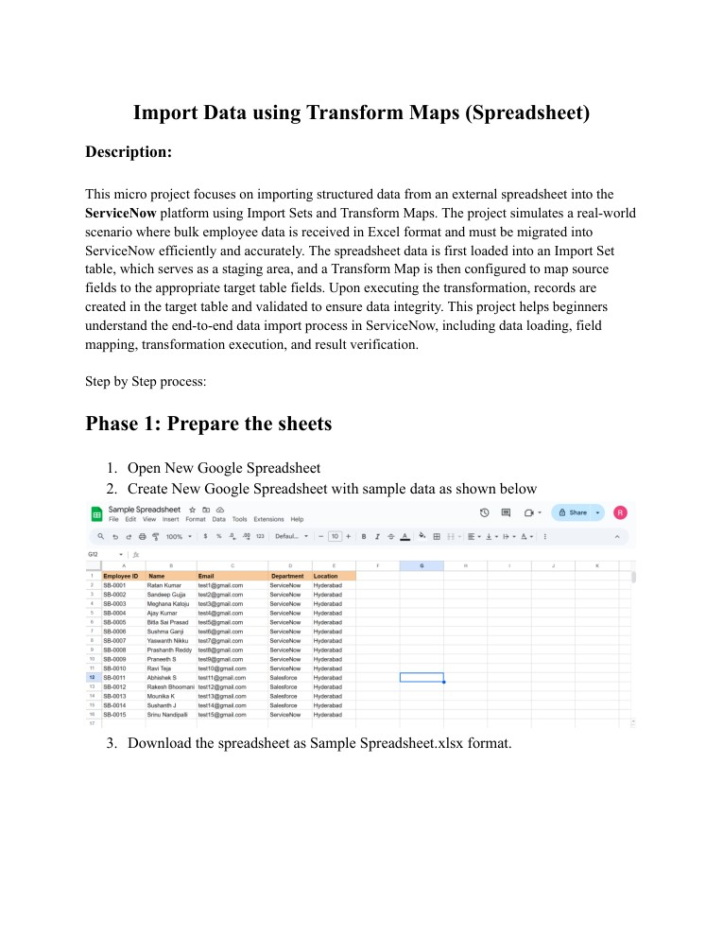
source page 1.
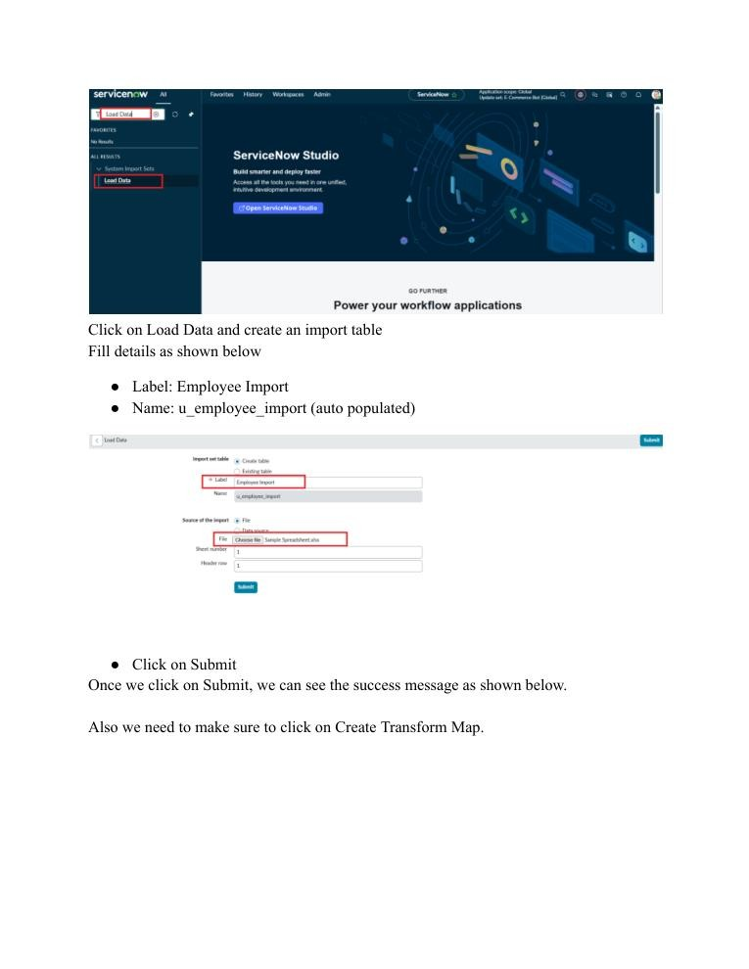
source page 5.
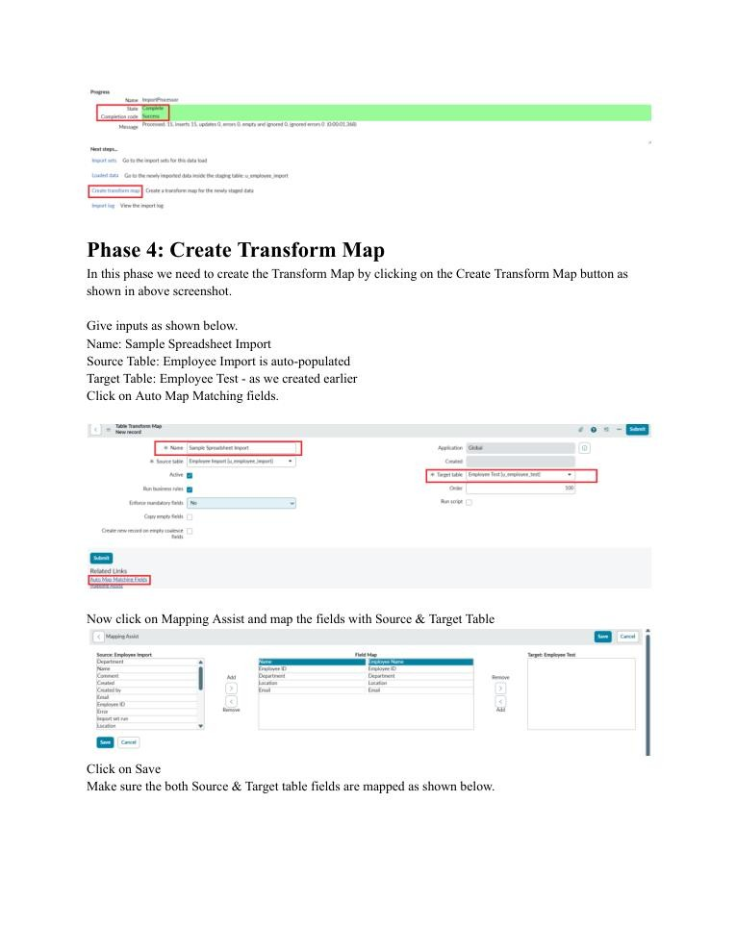
source page 6.
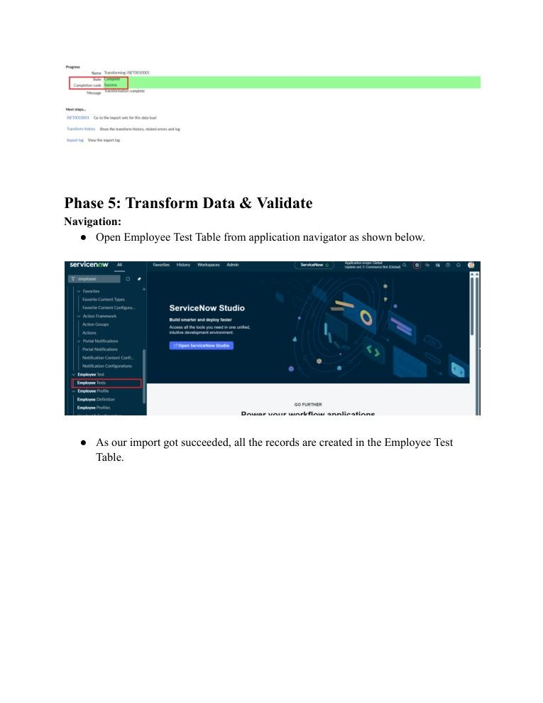
source page 8.
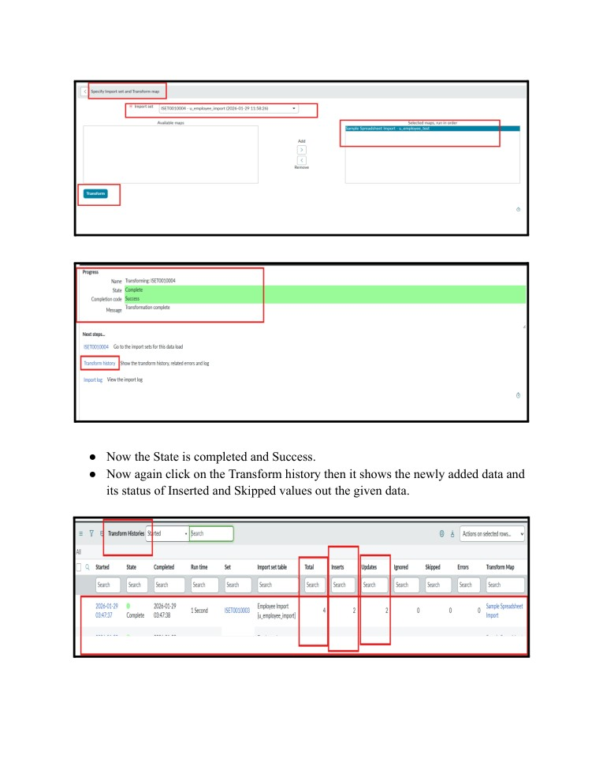
source page 15.

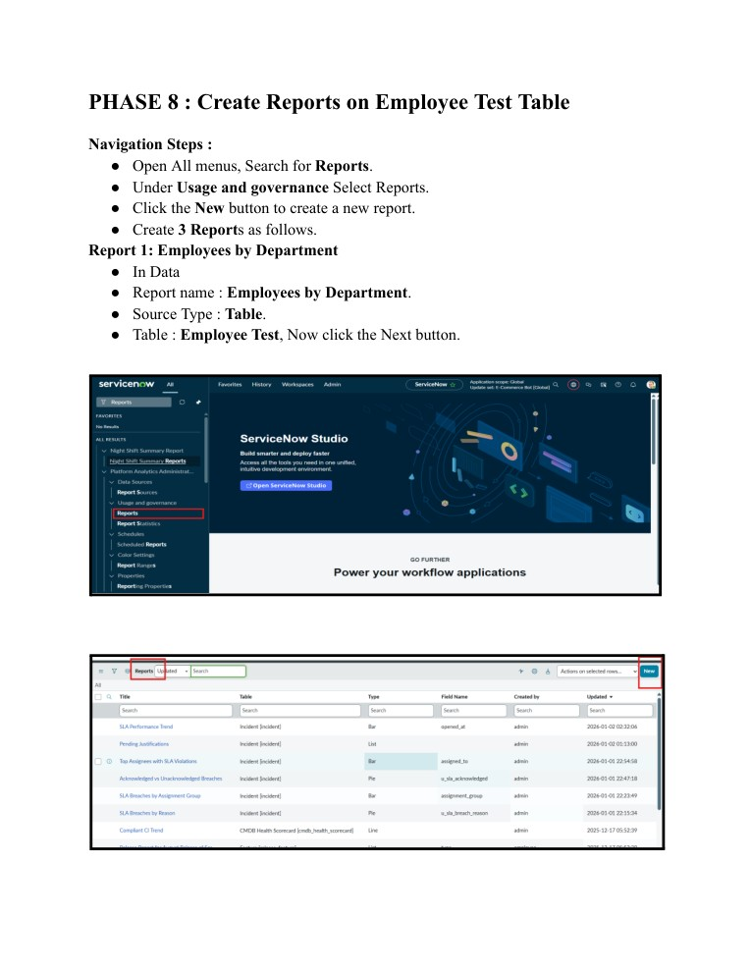
Figure 6. Source workflow screenshot source page 17.
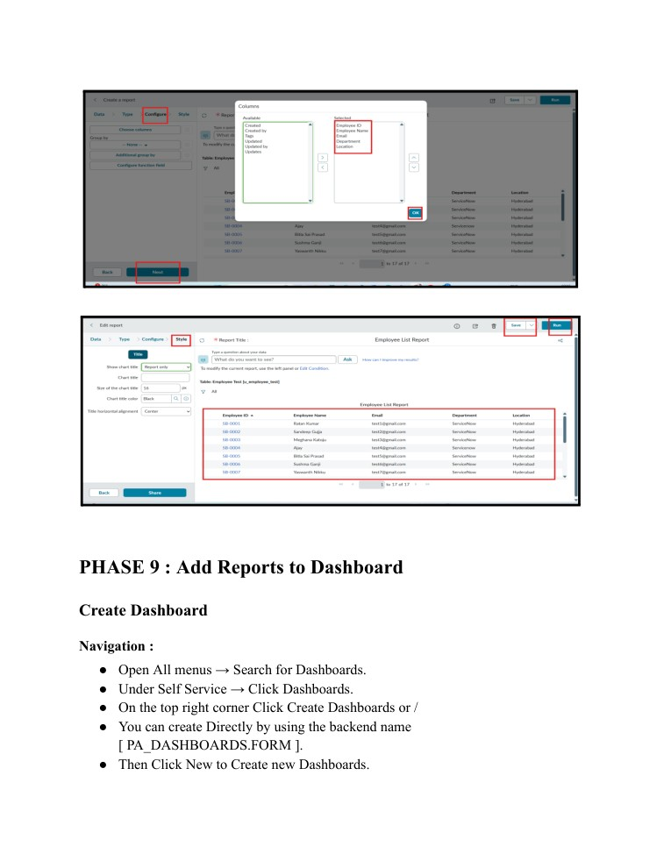
Figure 7. Source workflow screenshot source page 24.
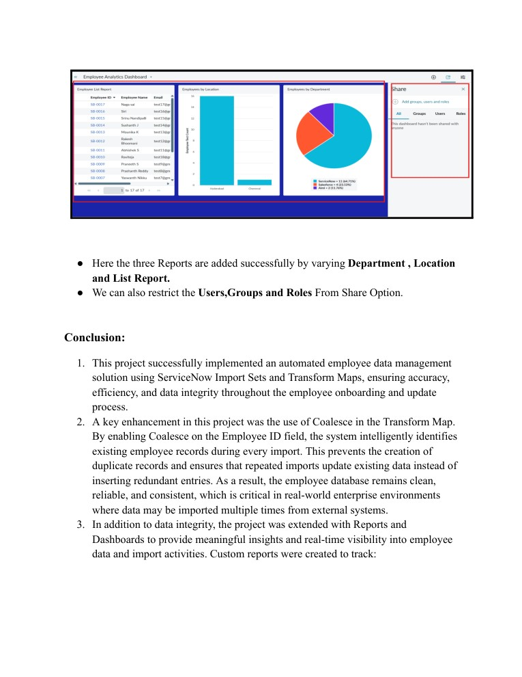
Figure 8. Source workflow screenshot — source page 30.

Testing
- Functional testing: Validate that transformed records appear in Employee Test.
- Import validation: Use Transform History to inspect inserted, updated, and ignored rows.
- Duplicate prevention: Enable Coalesce so repeated imports update the same employee records rather than creating duplicate records.
- Repeated import scenario: The source demonstrates new rows being inserted, existing rows being updated when values change, and repeated identical rows being ignored.

- Quantitative performance metrics such as latency, throughput, CPU usage, or memory usage are not specified in the source.

Screenshots or Demo
- The supplied source document contains screenshots of the import, transformation, validation, reporting, and dashboard workflow.
- No external demo URL is specified in the source.

Known Issues
- The workflow depends on correctly prepared spreadsheet data and correctly configured source-totarget mappings.
- The source does not document automated API integration, production deployment details, quantified performance testing, or a dedicated external authentication design.
- No other specific software bugs are documented in the source.

Future Enhancements
- Automate scheduled or recurring imports from additional external data sources.
- Add more data-quality validation rules before transformation.
- Expand dashboard and report metrics for employee and import monitoring.
- Introduce formal performance and security testing for production use.
- These are proposed extensions; they are not described as implemented features in the source.
Source basis: Import Data using Transform Maps (Spreadsheet). All project-specific details above are restricted to information supported by that source; unsupported template fields are explicitly marked as not specified.

